Nikto Lab Assignment
Launchinvg the application
- Go to applications icon
- Vulnrablity analysis
- Select nikto
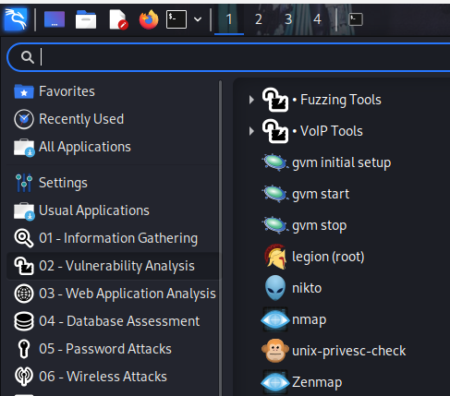
Home Page
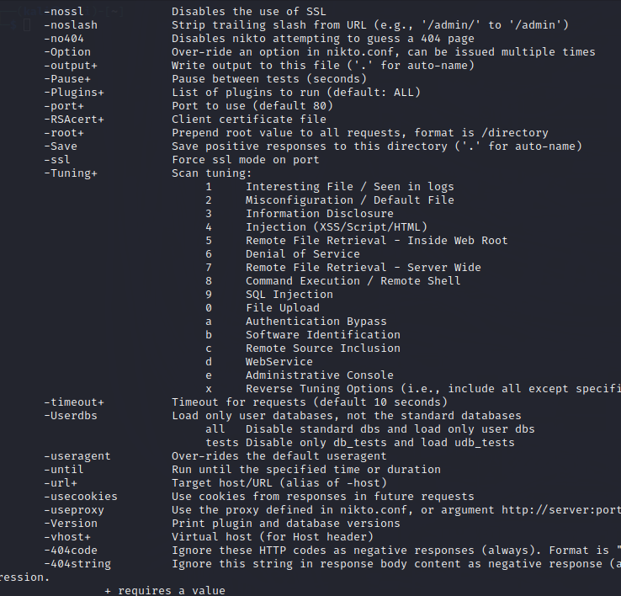
Scanning a web application
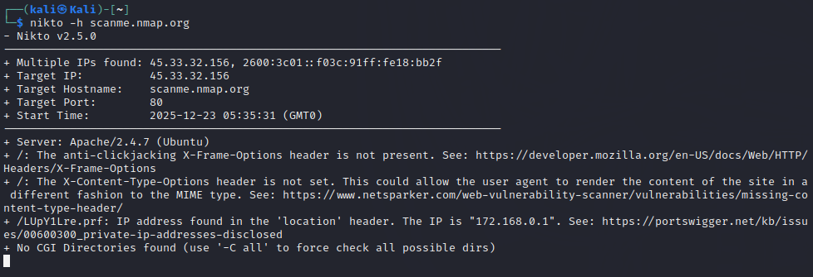
Vulnerabilities found by this scan: The X-Content-Type-Options header is not set
Copy link address and open it: https://www.netsparker.com/web-vulnerability-scanner/vulnerabilities/missing-content-type-header/
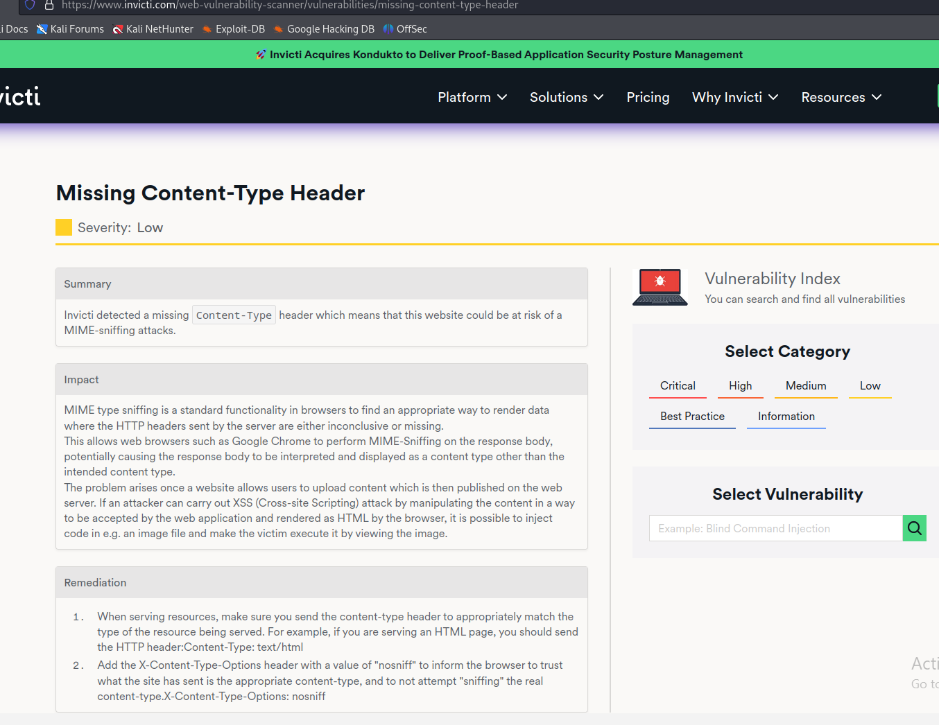

Scanning port 80 – target port 443
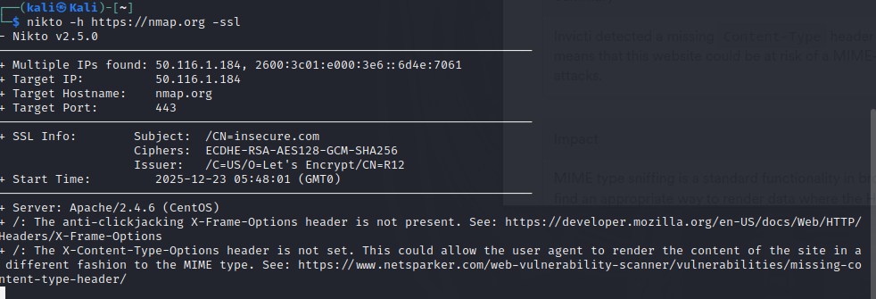
Scanning multiple web applications
- Create a text file – in this case we used NANO
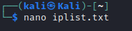
- List the IP addresses or domain name of web applications you want to scan
- Ctrl +A
- Ctrl + X – for exiting
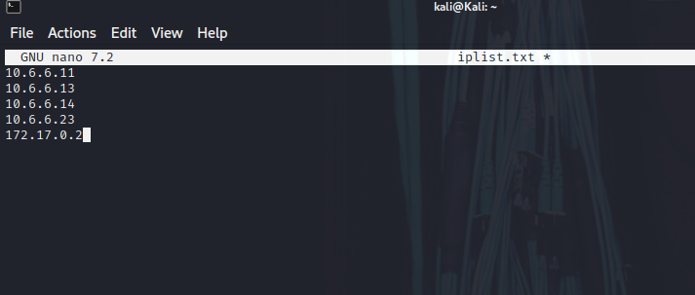

Results of the scanned 5 web applications:
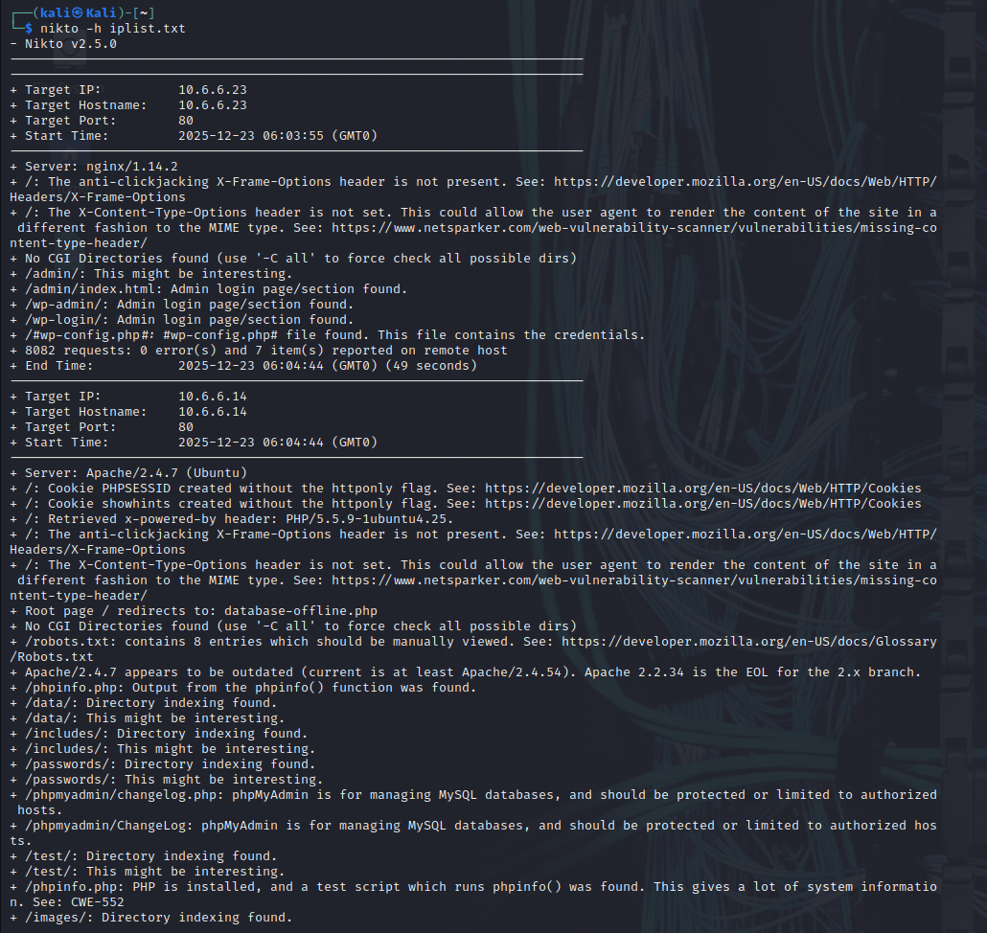

Saving the Report to a text file
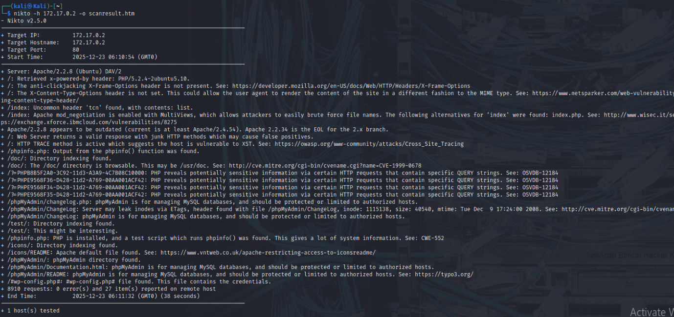

Opening the scan result .htm file
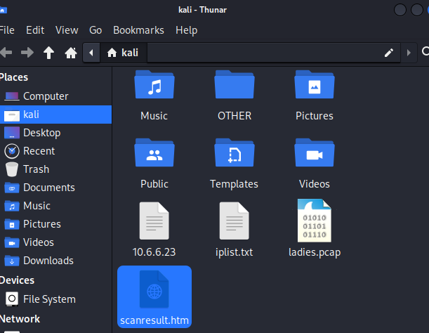
Opening in browser
